NORTHERN EDUCATION DIVISION MOCK EXAMINATION
2026 MALAWI SCHOOL CERTIFICATE OF EDUCATION
PHYSICS
Subject Number: M164/II
Wednesday, 1st April
Time Allowed: 2-hour sessions
10:00am onwards
PAPER II
Practical
(100 Marks)

Instructions
- This paper contains 6 printed pages. Please check.

- Write your Name at the top of the question paper and on all other sheets.

- Answer all the thirteen questions in the spaces provided.

- Use of electronic calculators is allowed.

- Maximum number of marks for each answer is indicated against each question.

- In the table provided on this page, tick against the question number you have answered.

- At the end of the examination, hand in your paper to the invigilator when time is called to stop writing.

Question Number | Tick if answered | Do not write in these columns
1
2
3
4
Total

Turn over

Section A (20 Marks)
Answer all the question in this section.
- With the aid of well labelled diagrams describe an experiment that can be carried out to demonstrate that resistance of a media affects the speed of an object falling through the media. Your description should include: 2 identical ball bearings, water, oil, 2 transparent jars of the same size.

__________________________________________________________________________________________________________________________________________________________________________________________________________________________________________________________________________________________________________________________________________________________________________________________________________________________________________________________________________________________________________________________________________________________________________________________________________________________________________________________________________________________________________________________________________________________________________________________________________________________________________________________________________________________________________________________________________________________________________________________________________________________________________________________________________________________________________________________________________________________________________________________________________________________________________________________________________________________
(10 marks)
- Describe an experiment that can be carried out to determine the length of a wire of resistance of 2 Ohms given a roll of wire.

____________________________________________________________________________________________________________________________________________________________________________________________________________________________________________________________________________________________________________________________________________________________________________________________________________________________________________________________________________________________________________________________________________________________________________________________________________________________________________________________________________________________________________________________________________________________________________________________________________________________________________________________________________________________________________________________________________________________________________________________________________________________________________________________________________________________________________________________________________________________________________________________________________________________________________________________________________________________________________________________________________________________________________________________________________________________________________________________________________________________________________________________________________________________________________________________________________________________________________________________________________________________________________________________________________________________________________________________________________________________________________________________________________________________________________________________________________________________________________________________________________ (10 marks)

- You are provided with a convex lens, a meter ruler, lens holder, white screen, a candle and matches.
- Arrange the apparatus as shown in figure 1.
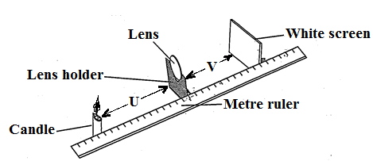
Figure 1`
- Place a candle at a distance of 15 cm from centre the lens (u).
- Light the candle.
- Move the screen until a clear image of the candle flame is focused onto the white screen.
- Measure the distance from the screen to the centre of the lens (v) and record in the table of results.
- Repeat the experiment using object distances of 20cm, 30cm and 40 cm
Table of results
Object distance (u), cm | Image distance (v), cm
15
20
30
40
(4 mark)
- Plot graph of image distance against object distance.
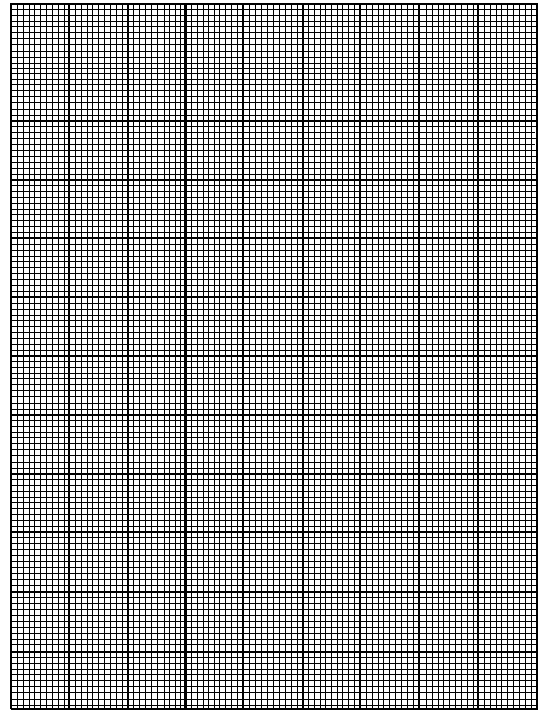
4 marks
- From the graph what would be the image distance, v when the object distance, u is 20 cm.
(1 mark)
- Use the graph to find the focal length of the lens.

(4 marks)
(1 mark)
- You are provided with a spring balance and masses of 100g and 200g.
  - Arrange the materials as shown in the figure 2 below.
100g spring balance
Pull
Desk

  - Pull the mass until when it just starts moving.
  - Note and record the reading from the spring balance in the table of results below.
  - Repeat the steps b. and c. using 200g mass.
Mass (g) | Reading of spring balance (N)
100
200
2 marks
  - Convert 200g to weight.

3 marks
  - Use the result in e to find coefficient of friction.

3 marks
  - Suggest any one error in this experiment.
_____________________________________________
1 mark
  - Suggest a way of minimizing the error in g.
________________________________________________
1 mark

